[Data in Brief 42 (2022) 108036](https://doi.org/10.1016/j.dib.2022.108036)



Contents lists available at [ScienceDirect](http://www.ScienceDirect.com/)

Data in Brief

journal homepage: [www.elsevier.com/locate/dib](http://www.elsevier.com/locate/dib)



Data Article

Título aún por discutirse Título aún por discutirse Título aún por discutirse

Autor a, Autor a,b,∗, Autor a

a *Faculty of Science and Marine Environment, Universiti Malaysia Terengganu, 21030 Kuala Nerus, Terengganu,*

*Malaysia*

b *Advanced Nano Materials (ANOMA) Research Group, Faculty of Science and Marine Environment, Universiti Malaysia Terengganu, 21030 Kuala Nerus, Terengganu, Malaysia*

a r t I c l e I n f o a b s t r a c t

*Article history:*

Received 18 October 2021

Revised 26 February 2022

Accepted 3 March 2022

Available online 8 March 2022

[Dataset link: The Data on Molecular Docking of Cinnamic Acid Amide on Dengue Viral Target NS2B/NS3 (Original data)](https://data.mendeley.com/datasets/838gm89sr2/1)

*Keywords:*

*In-silico* Natural Products Database

Peru

A natural occurring class compound, cinnamic acid is com- posed of a benzene ring, an alkene double bond and an acrylic acid functional group. Due to the feasibility of its structure modifications with a variety of compounds, cin- namic acids have been actively explored to improve their biological eﬃcacy. Cinnamic acid derivatives have been re- ported to exhibit an antimicrobial property. Despite the ben- eficial properties of cinnamic acid derivatives, the antivi- ral activity of the amide derivatives especially against the dengue virus is poorly defined. Herein, the cinnamic amide derivatives were evaluated for their potential as an anti- dengue virus through the *in-silico* analysis of the derivatives. This data aimed to analyze the interactions of the deriva- tives against the non-structural protein of viral target, dengue virus type 2 (DENV-2) NS2B/N3. The evaluation was based on binding aﬃnity, interaction type (bond type and distance) and interaction with amino acids. Three derivatives (CAA15, CAA16 and CAA17) with the best docking score were re- ported. Enhanced understanding of the interaction acquired from this analysis provide a useful information on for the

∗ Corresponding author at: Faculty of Science and Marine Environment, Universiti Malaysia Terengganu, Kuala Nerus, Terengganu 21030, Malaysia.

*E-mail address:* [asnu@umt.edu.my](mailto:asnu@umt.edu.my) (A. Asari).

<https://doi.org/10.1016/j.dib.2022.108036>

2352-3409/© 2022 The Author(s). Published by Elsevier Inc. This is an open access article under the CC BY license (<http://creativecommons.org/licenses/by/4.0/>)

prediction of the binding behavior aﬃnity of cinnamic amide derivatives and is ultimately useful in the rational design of drugs to synthesis new compounds with the potential bene- fits against DENV-2.

© 2022 The Author(s). Published by Elsevier Inc. This is an open access article under the CC BY license (<http://creativecommons.org/licenses/by/4.0/>)

# Speciﬁcations Table

Subject Chemistry

Specific subject area Molecular docking

Type of data Table

Image Figure

How data were acquired Molecular docking (AutoDock 4.2), ChemDraw Professional 16.0, OpenBabel

GUI, Discovery Studio 2020 Client.

Data format Raw

Analyzed

Parameters for data collection Docking score and interaction of the ligand with amino acid residues in the

binding pocket

Description of data collection The structure of cinnamic amide derivatives was constructed and energy minimized using ChemDraw software.

The minimized structures were docked on selected anti-viral targets using AutoDock software.

Data source location Institution: Universiti Malaysia Terengganu City/Town/Region: Kuala Nerus, Kuala Terengganu Country: Terengganu

Data accessibility Tables and Figures of the docking are accessible in the article.

Molecular docking files for Figure 2–4 are available at <https://data.mendeley.com/datasets/838gm89sr2/1>. doi: [10.17632/838gm89sr2.1](https://doi.org/10.17632/8381)

# Value of the Data

* The data provide on the interaction between cinnamic amide derivatives with the viral target NS2B/NS3 protease (NS2B/NS3pro) protein.
* The *in-silico* analysis of the antiviral properties of cinnamic amide derivatives may indicate the direction for future research in the field of anti-dengue therapy.
* The screening data help minimized research time considerably by enable the researchers to rapidly identify promising compounds and its interaction with the viral target.
* The data are useful for research scholars with insuﬃcient software and hardware require- ments which not affordable by them.
* The data can facilitate on the direction of the functional design of cinnamic amide derivatives specifically to target dengue virus infection.

# Data Description

The predominant circulating dengue virus (DENV) serotype is dengue virus type 2 (DENV-2). Although many research have been conducted in finding an effective antiviral against it, there is still no specific treatment currently available [1]. Nonetheless, there is emerging interest in de- velopment of an effective inhibitor against the NS2b/NS3 serine protease which responsible for seven different polyprotein cleavages in the virus life cycle [2]. Cinnamic acid (Fig. 1) occur in all green plant and is known for their various biological activities [3,4]. The provided docking data

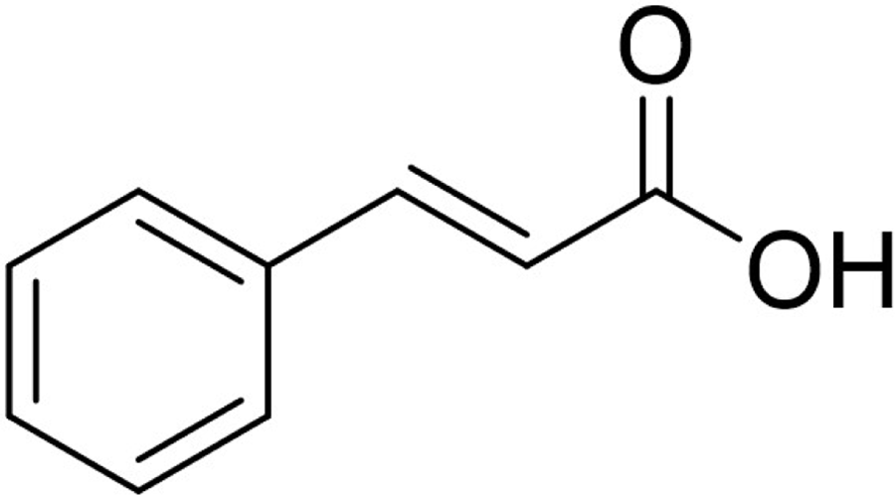

**Fig. 1.** Structure of cinnamic acid.

**Table 1**

DENV target used in docking.

Protein PDB ID Resolution

1. NS2B-NS3 Protease Model – Homologous crystal structure of –

DENV-2 NS2B/NS3pro [4]

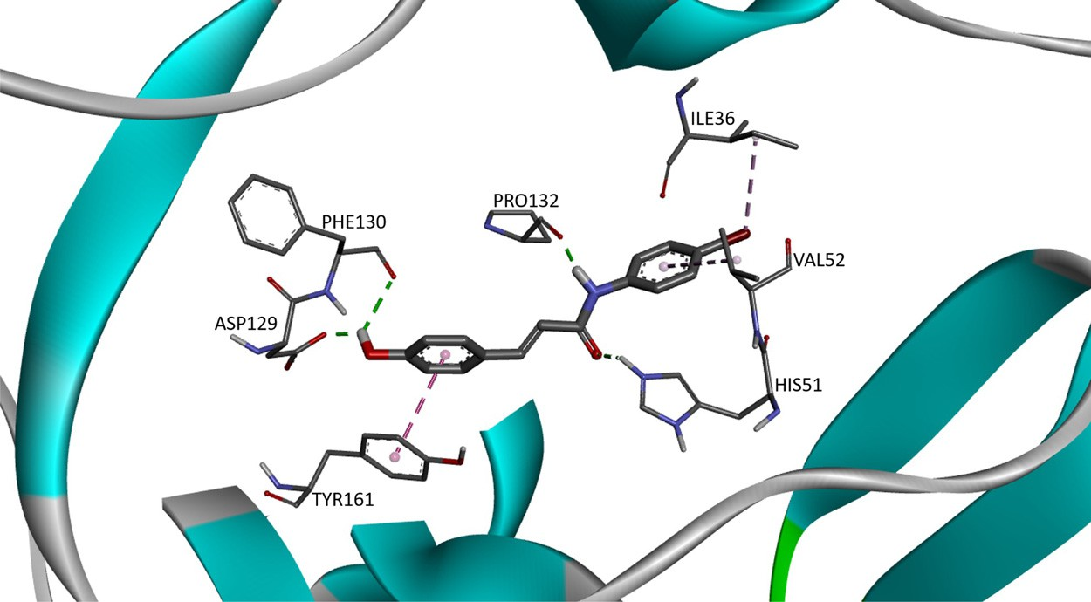

**Fig. 2.** The 3D interaction of compound CAA15 (FEB: −7.22) against viral target NS2B/NS3pro.

of 30 cinnamic amide derivatives against DENV-2 may be useful to develop new drug candidates for the treatment of DENV infections. In this article, Table 1 provides the details of the viral tar- get (as retrieved from Wichapong et al [5].), Table 2 provides the structure of cinnamic amide derivatives, while the free binding energy, interaction type and bond length of the docking are shown in Table 3. The 3D interaction of the top 3 best-docked compounds with the target are shown in Figs. 2–4. The selection was made based on the lowest free binding energy with the highest number of Hydrogen bonding.

**Table 2**

List of cinnamic acids and cinnamic amide derivatives. No. Ligand Structure

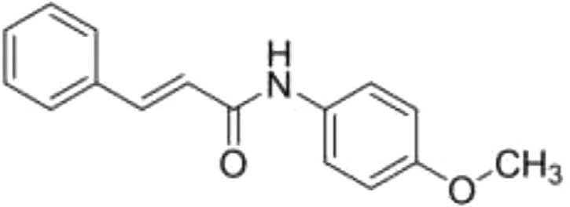

1.

CAA01

1. CAA02

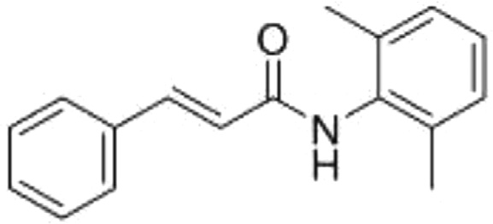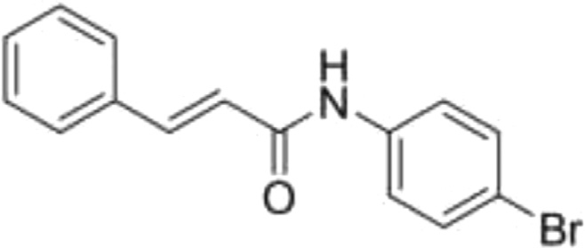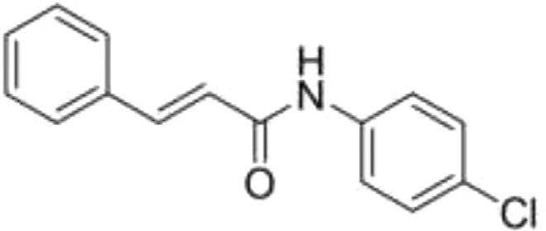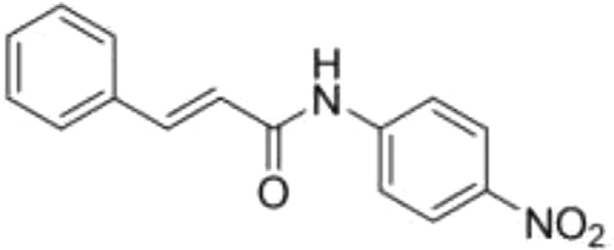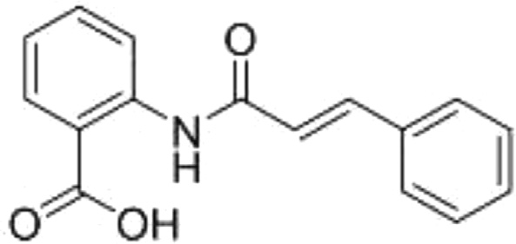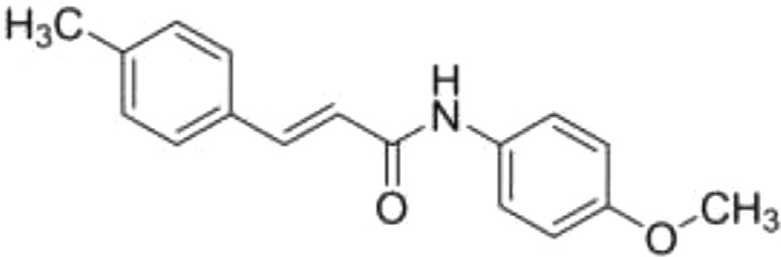

1. CAA03
2. CAA04
3. CAA05
4. CAA06

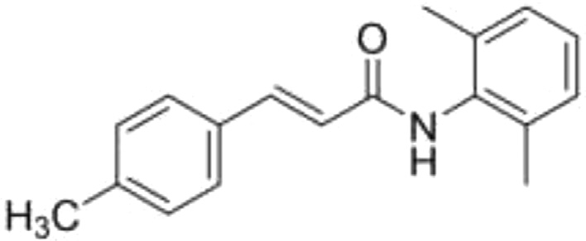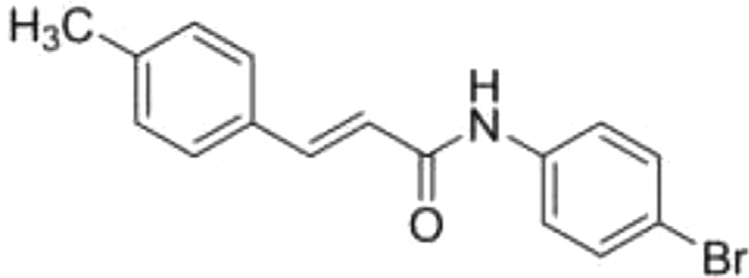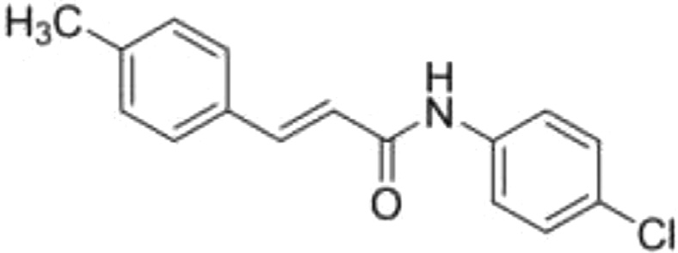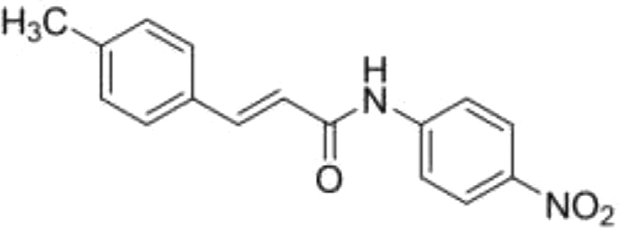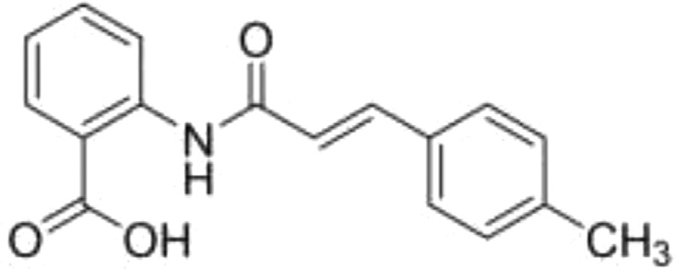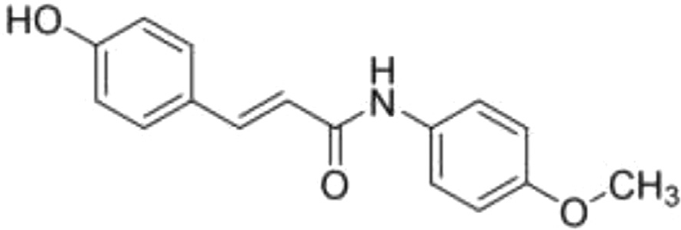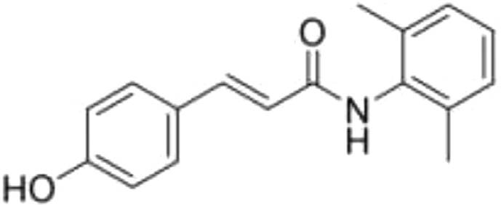

**Table 2** (*continued*)

No. Ligand Structure

1. CAA08
2. CAA09
3. CAA10
4. CAA11
5. CAA12
6. CAA13

**Table 2** (*continued*)

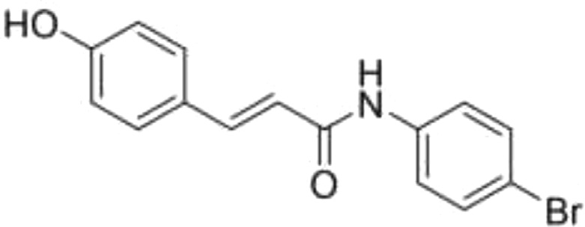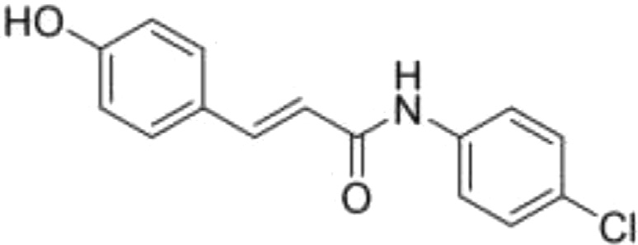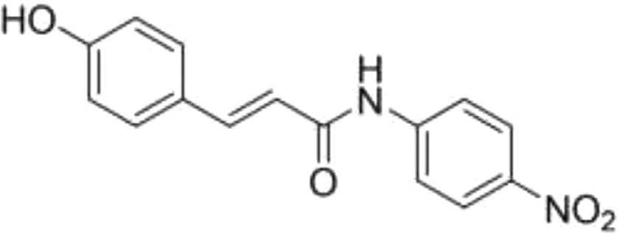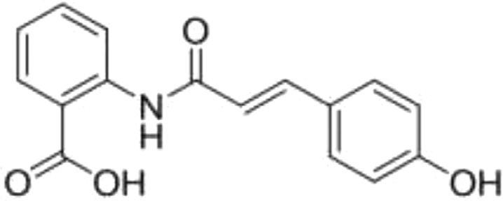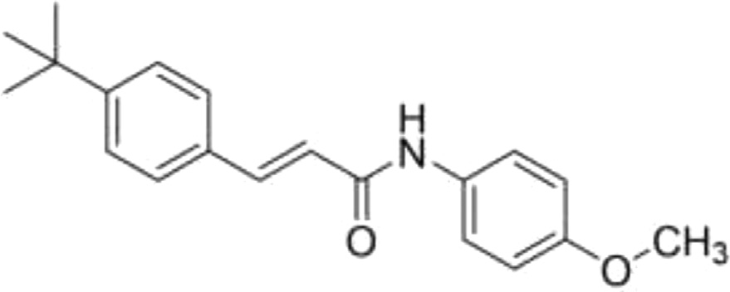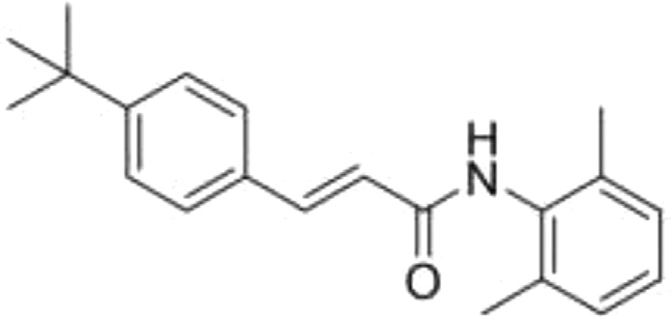

No. Ligand Structure

1. CAA15
2. CAA16
3. CAA17
4. CAA18
5. CAA19

**Table 2** (*continued*)

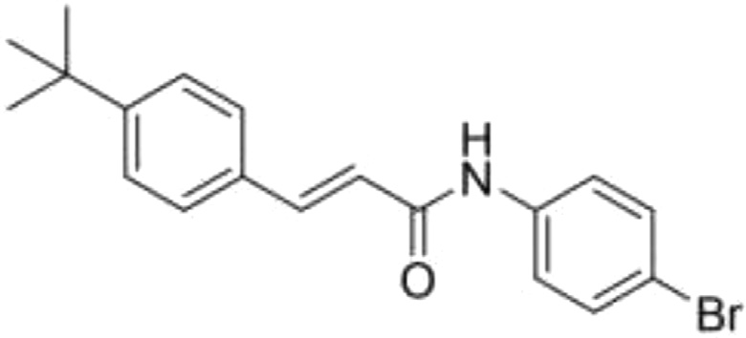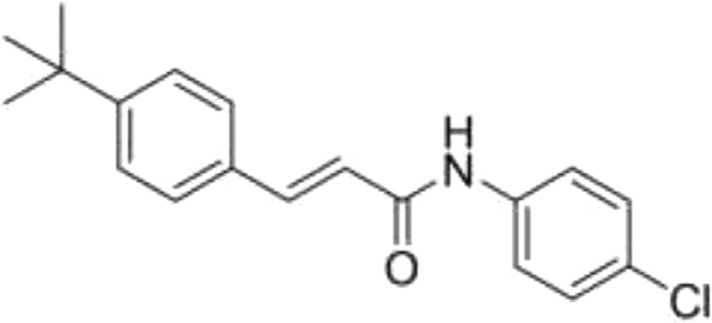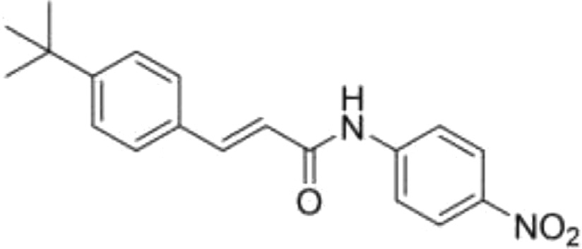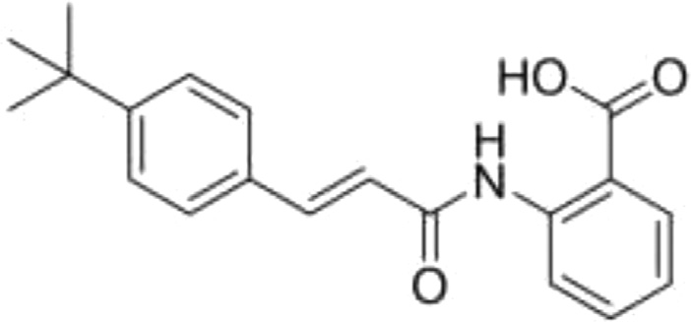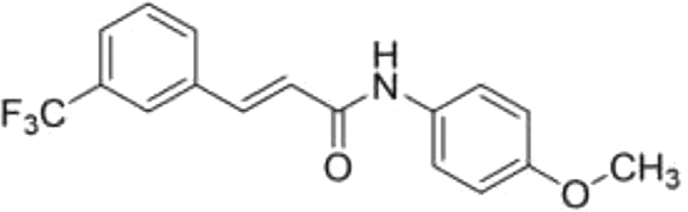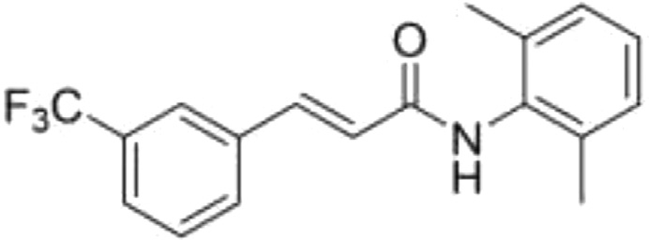

No. Ligand Structure

1. CAA21
2. CAA22
3. CAA23
4. CAA24
5. CAA25

**Table 2** (*continued*)

No. Ligand Structure

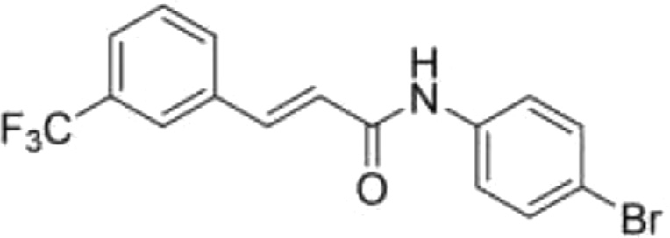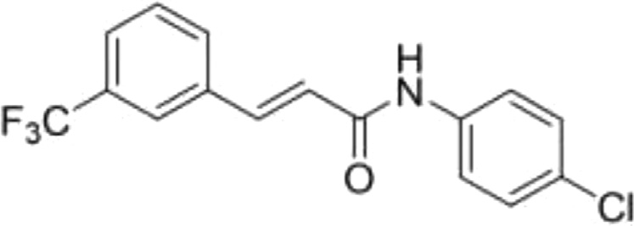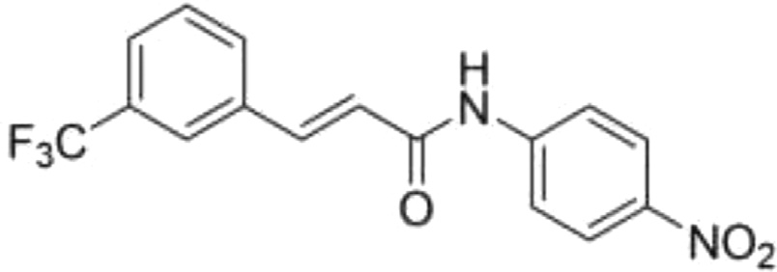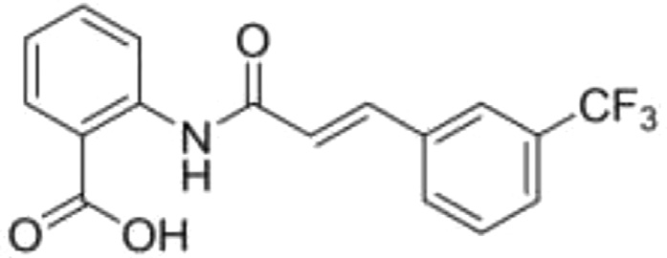

27.

CAA27

28.

CAA28

29.

CAA29

30.

CAA30

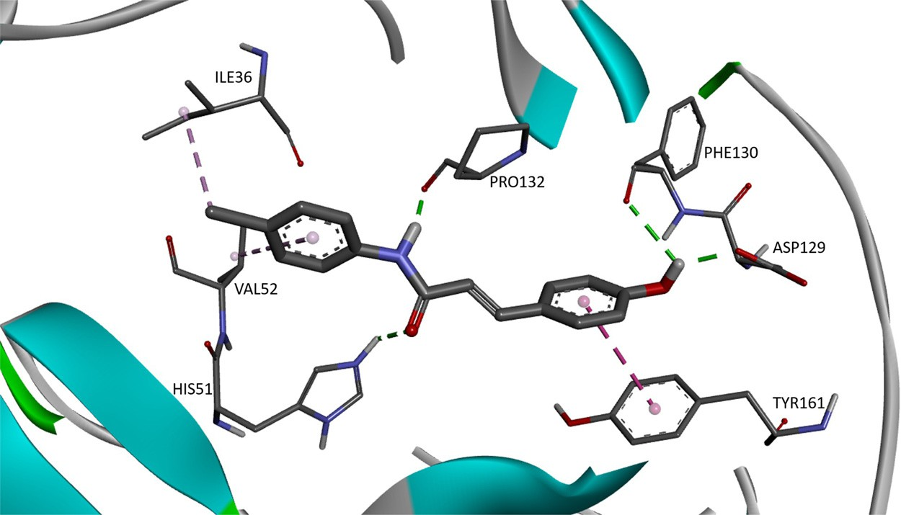

**Fig. 3.** The 3D interaction of compound CAA16 (FEB: −7.03) against viral target NS2B/NS3pro.

**Table 3**

Cinnamic amide derivatives and their interactions.

|  |  |  |  |  |  |
| --- | --- | --- | --- | --- | --- |
| Sr. No. | Ligand | Free Binding energy, FEB (kcal/mol) | Interaction | Type of interaction | Bond distance (A˚ ) |
| 1. | CAA01 | −6.66 | ILE B:36 | *π* -Alkyl | 4.94 |
|  |  |  |  | *π* -Lone pair | 2.81 |
|  |  |  | VAL B:52 | *π* -Alkyl | 5.24 |
|  |  |  | ASP B:129 | Carbon H-Bond | 3.01 |
|  |  |  | PHE B:130 | H-Bond | 2.71 |
|  |  |  | PRO B:132 | H-Bond | 2.18 |
|  |  |  |  | *π* -Alkyl | 5.19 |
|  |  |  | TYR B:161 | *π* -*π* Stacked | 5.62 |
|  |  |  |  | *π* -Sigma | 3.66 |
| 2. | CAA02 | −6.56 | ILE B:36 | *π* -Alkyl | 5.28 |
|  |  |  |  | Pi-Lone pair | 2.89 |
|  |  |  | VAL B:52 | *π* -Alkyl | 2.35 |
|  |  |  | HIS B:51 | H-Bond | 2.08 |
|  |  |  | SER B:135 | H-Bond | 1.90 |
|  |  |  | TYR B:150 | *π* -Alkyl | 4.82 |
| 3. | CAA03 | −6.60 | ILE B:36 | Alkyl | 3.94 |
|  |  |  |  | *π* -Alkyl | 5.27 |
|  |  |  | VAL B:52 | *π* -Alkyl | 5.34 |
|  |  |  | PRO B:132 | H-Bond | 1.98 |
| 4. | CAA04 | −6.45 | ILE B:36 | Alkyl | 3.83 |
|  |  |  |  | *π* -Alkyl | 5.39 |
|  |  |  | VAL B:52 | *π* -Alkyl | 5.31 |
|  |  |  | PRO B:132 | H-Bond | 2.00 |
| 5. | CAA05 | −6.85 | ARG B:54 | 3 H-Bonds | 1.75, 2.37, 2.63 |
|  |  |  | PRO B:132 | H-Bond | 2.51 |
|  |  |  | TYR B:150 | *π* -Alkyl | 5.22 |
|  |  |  | TYR B:161 | *π* -Alkyl | 5.17 |
| 6. | CAA06 | −6.01 | HIS B:51 | Carbon H-Bond | 3.26 |
|  |  |  |  | *π* -*π* Stacked | 5.45 |
|  |  |  | ASP B:75 | Pi-Anion | 3.28 |
|  |  |  | SER A:83 | Carbon H-Bond | 3.07 |
|  |  |  | MET A:84 | H-Bond | 1.95 |
|  |  |  | ASN B:152 | 2 H-Bonds | 1.78, 2.00 |
|  |  |  | GLY B:153 | Pi-Donor H-Bond | 3.07 |
| 7. | CAA07 | −6.66 | TRP B:50 | *π* -Alkyl | 5.07 |
|  |  |  | VAL B:72 | Alkyl | 4.77 |
|  |  |  | ILE A:86 | Alkyl | 4.06 |
|  |  |  | GLY B:153 | H-Bond | 2.05 |
|  |  |  | VAL B:154 | *π* -Sigma | 3.72 |
|  |  |  |  | Alkyl | 4.16 |
|  |  |  | VAL B:155 | H-Bond | 1.91 |
|  |  |  |  | *π* -Alkyl | 5.07 |
|  |  |  |  | Alkyl | 5.07 |
| 8. | CAA08 | −6.81 | ILE B:36 | *π* -Alkyl | 5.29 |
|  |  |  |  | Alkyl | 3.61 |
|  |  |  |  | Pi-Lone pair | 2.95 |
|  |  |  | HIS B:51 | H-Bond | 2.04 |
|  |  |  | VAL B:52 | *π* -Alkyl | 5.25 |
|  |  |  | SER B:135 | H-Bond | 1.86 |
|  |  |  | TYR B:150 | *π* -Alkyl | 4.81 |

|  |  |  |  |  |  |
| --- | --- | --- | --- | --- | --- |
| Sr. No. | Ligand | Free Binding  energy, FEB (kcal/mol) | Interaction | Type of interaction | Bond distance (A˚ ) |
| 9. | CAA09 | −6.75 | ILE B:36 | *π* -Alkyl | 5.45 |
|  |  |  |  | Alkyl | 3.85 |
|  |  |  | HIS B:51 | H-Bond | 1.98 |
|  |  |  | VAL B:52 | *π* -Alkyl | 5.31 |
|  |  |  | PRO B:132 | H-Bond | 1.85 |
|  |  |  | TYR B:150 | *π* -Alkyl | 5.27 |
|  |  |  | TYR B:161 | *π* -Sigma | 3.74 |
|  |  |  |  | *π* -*π* Stacked | 4.53 |
| 10. | CAA10 | −6.61 | ILE B:36 | *П*-Alkyl | 5.24 |
|  |  |  |  | Alkyl | 3.55 |
|  |  |  | PRO B:132 | H-Bond | 1.83 |
|  |  |  |  | *π* -Alkyl | 5.09 |
|  |  |  | TYR B:161 | *π* -Alkyl | 3.61 |
| 11. | CAA11 | −6.72 | HIS B:51 | H-Bond | 2.11 |
|  |  |  |  | *π* -Cation | 4.83 |
|  |  |  |  | *π* -*π* T-shaped | 5.20 |
|  |  |  | ARG B:54 | 3 H-Bonds | 1.85, 2.56, 2.60 |
|  |  |  | PRO B:132 | *π* -Alkyl | 5.22 |
|  |  |  | SER B:135 | H-Bond | 2.20 |
|  |  |  | TYR B:161 | *π* -*π* T-shaped | 3.90 |
|  |  |  |  | *π* -Sigma | 5.11 |
| 12. | CAA12 | −5.99 | ILE B:36 | *π* -Alkyl | 5.23 |
|  |  |  |  | Alkyl | 3.47 |
|  |  |  | VAL B:52 | *π* -Alkyl | 5.24 |
|  |  |  | PRO B:132 | H-Bond | 1.98 |
|  |  |  | GLY B:151 | H-Bond | 1.98 |
| 13. | CAA13 | −6.66 | ILE B:36 | *π* -Alkyl | 5.26 |
|  |  |  |  | Alkyl | 4.46 |
|  |  |  |  | *π* -Lone pair | 2.95 |
|  |  |  | HIS B:51 | H-Bond | 2.18 |
|  |  |  | VAL B:52 | *π* -Alkyl | 5.24 |
|  |  |  | ASP B:29 | H-Bond | 2.76 |
|  |  |  | PHE B:130 | H-Bond | 1.97 |
|  |  |  | PRO B:132 | H-Bond | 1.81 |
|  |  |  | TYR B:161 | *π* -*π* Stacked | 4.67 |
| 14. | CAA14 | −7.05 | HIS B:51 | *π* -Alkyl | 3.87 |
|  |  |  | VAL B:52 | *π* -Alkyl | 5.33 |
|  |  |  |  | Alkyl | 3.58 |
|  |  |  | ASP B:29 | H-Bond | 2.39 |
|  |  |  | PHE B:130 | H-Bond | 2.07 |
|  |  |  | PRO B:132 | H-Bond | 1.97 |
|  |  |  |  | Alkyl | 4.62 |
|  |  |  | TYR B:161 | *π* -*π* Stacked | 4.35 |
| 15. | CAA15 | −7.22 | ILE B:36 | Alkyl | 4.15 |
|  |  |  | HIS B:51 | H-Bond | 2.13 |
|  |  |  | VAL B:52 | *π* -Alkyl | 5.42 |
|  |  |  | ASP B:29 | H-Bond | 1.91 |
|  |  |  | PHE B:130 | H-Bond | 2.43 |
|  |  |  | PRO B:132 | H-Bond | 1.73 |
|  |  |  | TYR B:161 | *π* -*π* Stacked | 4.15 |

**Table 3** (*continued*)

|  |  |  |  |  |  |
| --- | --- | --- | --- | --- | --- |
| Sr. No. | Ligand | Free Binding energy, FEB (kcal/mol) | Interaction | Type of interaction | Bond distance (A˚ ) |
| 16. | CAA16 | −7.03 | ILE B:36 | Alkyl | 4.14 |
|  |  |  | HIS B:51 | H-Bond | 2.17 |
|  |  |  | VAL B:52 | *π* -Alkyl | 5.37 |
|  |  |  | ASP B:29 | H-Bond | 1.93 |
|  |  |  | PHE B:130 | H-Bond | 2.56 |
|  |  |  | PRO B:132 | H-Bond | 1.69 |
|  |  |  | TYR B:161 | *π* -*π* Stacked | 4.16 |
| 17. | CAA17 | −7.07 | VAL B:52 | *π* -Alkyl | 5.47 |
|  |  |  | ARG B:54 | 2 H-Bonds | 2.02, 2.68 |
|  |  |  | ASP B:29 | H-Bond | 2.73 |
|  |  |  | PHE B:130 | H-Bond | 1.97 |
|  |  |  | PRO B:132 | H-Bond | 2.20 |
|  |  |  | TYR B:161 | *π* -*π* Stacked | 4.62 |
| 18. | CAA18 | −6.23 | GLN B:35 | H-Bond | 2.34 |
|  |  |  | ILE B:36 | *π* -Lone pair | 2.88 |
|  |  |  |  | *π* -Alkyl | 5.20 |
|  |  |  | VAL B:52 | *π* -Alkyl | 5.23 |
|  |  |  | ASP B:29 | H-Bond | 2.99 |
|  |  |  | PHE B:130 | H-Bond | 1.96 |
|  |  |  | PRO B:132 | H-Bond | 1.81 |
|  |  |  | TYR B:161 | *π* -*π* Stacked | 5.13 |
| 19. | CAA19 | −7.74 | TRP B:50 | *π* -Alkyl | 5.04 |
|  |  |  | VAL B:72 | Alkyl | 4.83 |
|  |  |  | ILE A:86 | Alkyl | 4.03 |
|  |  |  | GLY B:153 | H-Bond | 2.05 |
|  |  |  | VAL B:154 | *π* -Sigma | 3.69 |
|  |  |  |  | Alkyl | 4.09 |
|  |  |  | VAL B:155 | H-Bond | 1.90 |
|  |  |  |  | *π* -Alkyl | 5.07 |
|  |  |  |  | Alkyl | 5.12 |
| 20. | CAA20 | −7.18 | TRP B:50 | *π* -Alkyl | 5.08 |
|  |  |  | VAL B:72 | Alkyl | 4.91 |
|  |  |  | GLY B:153 | H-Bond | 2.09 |
|  |  |  | VAL B:154 | *π* -Alkyl | 5.40 |
|  |  |  | VAL B:155 | *π* -Alkyl | 4.83 |
|  |  |  |  | Alkyl | 5.03 |
|  |  |  | TYR B:161 | *π* -Alkyl | 5.00 |
| 21. | CAA21 | −7.36 | TRP B:50 | *π* -Alkyl | 4.97 |
|  |  |  | HIS B:51 | *π* -*π* Stacked | 4.44 |
|  |  |  | VAL B:72 | Alkyl | 4.97 |
|  |  |  | ASP B:75 | *π* -Cation | 3.85 |
|  |  |  | PHE B:130 | Halogen | 3.10 |
|  |  |  | GLY B:153 | H-Bond | 2.12 |
|  |  |  | TYR B:161 | *π* -Alkyl | 3.98 |
|  |  |  |  | *π* -*π* Stacked | 4.10 |
| 22. | CAA22 | −7.14 | TRP B:50 | *π* -Alkyl | 5.10 |
|  |  |  | HIS B:51 | *π* -*π* Stacked | 4.36 |
|  |  |  | VAL B:72 | Alkyl | 5.07 |
|  |  |  | ASP B:75 | *π* -Anion | 3.97 |
|  |  |  | GLY B:153 | H-Bond | 2.12 |
|  |  |  | TYR B:161 | *π* -Alkyl | 4.21 |
|  |  |  |  | *π* -*π* Stacked | 4.18 |

|  |  |  |  |  |  |
| --- | --- | --- | --- | --- | --- |
| Sr. No. | Ligand | Free Binding  energy, FEB (kcal/mol) | Interaction | Type of interaction | Bond distance (A˚ ) |
| 23. | CAA23 | −7.24 | ILE B:36 | *π* -Alkyl | 4.86 |
|  |  |  | ARG B:54 | H-Bond | 2.28 |
|  |  |  | PRO B:132 | *π* -Alkyl | 4.61 |
|  |  |  | SER B:135 | Carbon H-Bond | 4.36 |
|  |  |  | TYR B:161 | *π* -Alkyl | 4.48 |
|  |  |  |  | 2 *π* -Sigma | 3.71, 3.90 |
| 24. | CAA24 | −6.56 | SER B:135 | 3 H-Bonds | 1.99, 2.10, 3.01 |
|  |  |  | VAL B:155 | *π* -Alkyl | 4.97 |
| 25. | CAA25 | −6.70 | GLN B:35 | Halogen | 3.08 |
|  |  |  | ILE B:36 | *π* -Alkyl | 4.95 |
|  |  |  |  | Alkyl | 4.97 |
|  |  |  |  | *π* -Lone pair | 2.80 |
|  |  |  | VAL B:52 | *π* -Alkyl | 5.35 |
|  |  |  | ASP B:29 | Carbon H-Bond | 2.97 |
|  |  |  | PHE B:130 | H-Bond | 2.76 |
|  |  |  | PRO B:132 | H-Bond | 2.12 |
|  |  |  |  | *π* -Alkyl | 5.22 |
|  |  |  | TYR B:161 | *π* -Sigma | 3.71 |
|  |  |  |  | *π* -*π* Stacked | 5.58 |
| 26. | CAA26 | −6.75 | GLN B:35 | 2 Halogen | 2.99, 3.68 |
|  |  |  | ILE B:36 | *π* -Alkyl | 5.38 |
|  |  |  |  | Alkyl | 5.26 |
|  |  |  |  | *π* -Lone pair | 2.87 |
|  |  |  |  | Carbon H-Bond | 4.14 |
|  |  |  |  | Halogen | 3.37 |
|  |  |  | VAL B:52 | *π* -Alkyl | 5.43 |
|  |  |  | HIS B:51 | H-Bond | 2.19 |
|  |  |  | PRO B:132 | Alkyl | 5.03 |
|  |  |  | SER B:135 | H-Bond | 1.92 |
|  |  |  | TYR B:150 | *π* -Alkyl | 4.75 |
| 27. | CAA27 | −6.70 | ILE B:36 | *π* -Alkyl | 5.25 |
|  |  |  |  | Alkyl | 3.95 |
|  |  |  | VAL B:52 | *π* -Alkyl | 5.32 |
|  |  |  | ASP B:29 | 2 Halogens | 2.78, 3.46 |
|  |  |  | PHE B:130 | Halogen | 3.70 |
|  |  |  | PRO B:132 | H-Bond | 1.97 |
|  |  |  | TYR B:161 | *π* -Alkyl | 3.81 |
| 28. | CAA28 | −6.52 | ILE B:36 | *π* -Alkyl | 5.26 |
|  |  |  |  | Alkyl | 3.89 |
|  |  |  | VAL B:52 | *π* -Alkyl | 5.35 |
|  |  |  | ASP B:29 | 2 Halogens | 2.77, 3.65 |
|  |  |  | PRO B:132 | H-Bond | 1.95 |
|  |  |  | TYR B:161 | *π* -Alkyl | 3.70 |
| 29. | CAA29 | −6.95 | ARG B:54 | 2 H-Bonds | 1.79, 2.19 |
|  |  |  | ASP B:29 | 2 Halogens | 3.03, 3.60 |
|  |  |  | PHE B:130 | 2 Halogens | 3.15, 3.46 |
|  |  |  | PRO B:132 | H-Bond | 2.84 |
|  |  |  |  | *π* -Alkyl | 5.31 |
|  |  |  | TYR B:161 | *π* -Alkyl | 3.75 |
|  |  |  |  | *π* -Lone pair | 2.89 |
|  |  |  |  | *π* -*π* Stacked | 5.48 |

**Table 3** (*continued*)

|  |  |  |  |  |  |
| --- | --- | --- | --- | --- | --- |
| Sr. No. | Ligand | Free Binding energy, FEB (kcal/mol) | Interaction | Type of interaction | Bond distance (A˚ ) |
| 30. | CAA30 | −5.89 | HIS B:51 | H-Bond | 2.90 |
|  |  |  | SER A:83 | 2 Halogens | 3.52, 3.60 |
|  |  |  | MET A:84 | H-Bond | 2.07 |
|  |  |  |  | 2 Halogens | 2.07, 2.61 |
|  |  |  | SER B:135 | H-Bond | 2.76 |
|  |  |  | ASN B:152 | Halogen | 3.23 |
|  |  |  | GLY B:153 | Halogen | 3.01 |
|  |  |  | VAL B:155 | Alkyl | 5.36 |

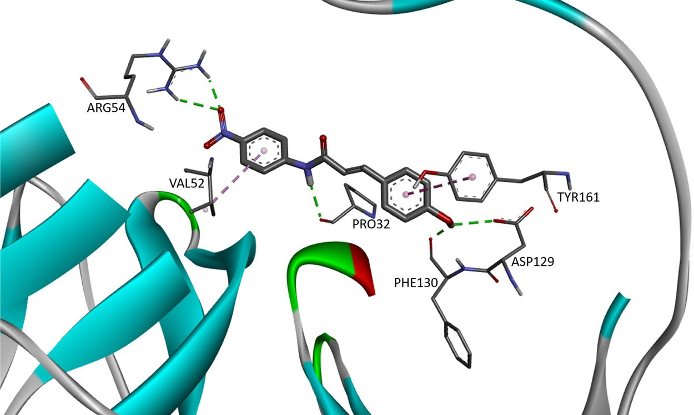

**Fig. 4.** The 3D interaction of compound CAA17 (FEB: −7.07) against viral target NS2B/NS3pro.

# Experimental Design, Materials and Methods

* 1. *. Selection and retrieval of targets structures*

The virtual screening was carried out on the homology model of the dengue virus’s non- structural protein, NS2B/NS3pro developed by Wichapong et al [5]. The DENV-2 NS2B/NS3pro model was built based on the DENV-2 complex cofactor-protease using the crystal structure of NS2B/NS3pro West Nile Virus (WNV) as the template. The protein structure was prepared as [a macromolecule prior to docking using AutoDock version 1.5.6 package (www.autodock.scrips. edu). Briefly, the protein preparation was done by removing the native ligand, tetrapeptide in-](http://www.autodock.scrips.edu/) hibitor (Bz-Nle-Lys-Ar-H) and water molecules, the addition of polar hydrogen and Kollmann charges.

* 1. *Ligand preparation and molecular docking*

The 3D structures of 30 cinnamic amide derivatives were constructed and energetically op- timized using ChemDraw Professional 16.0. The minimised structures were saved in sdf format before being converted into pdb format using OpenBabel-3.1.1 software [6].

The validation of docking protocol was done by re-docking the inhibitor tetrapeptide (Bz-Nle- Lys-Ar-H) with the RMSD value not greater than 2.0 A˚ . The ligands were prepared by merging of non-polar hydrogen and assigned Gasteiger charged. The center of the grid box was employed around the protease active site at 23.038, 43.372, −0.316 in x, y, and z coordinate, respectively, with a box size of 60 × 60 × 60 dimensions and grid spacing 0.375 A˚ . The docking of lig- ands was run with the Lamarckian Genetics Algorithm (GA) search program applied to generate 100 runs. The binding modes of compounds were analyzed using Discovery Studio Client 2020 ([www.accelrys.com](http://www.accelrys.com/)).

The identification of hit compound was identified based on the conformations with the ones of lowest free binding energy and of the most populated cluster.

# Declaration of Competing Interest

The authors declare that they have no known competing financial interests or personal rela- tionships which have or could be perceived to have influenced the work reported in this article.

# Data Availability

[The Data on Molecular Docking of Cinnamic Acid Amide on Dengue Viral Target NS2B/ NS3 (Original data) (Mendeley Data)](https://data.mendeley.com/datasets/838gm89sr2/1)

# CRediT Author Statement

**Nadia Mohamed Yusoff:** Data curation, Investigation, Methodology, Software, Writing – original draft; **Asnuzilawati Asari:** Conceptualization, Supervision; **Siti Nor Khadijah Addis:** Methodology, Validation, Writing – review & editing.

# Acknowledgments

This research was fully funded by the [Ministry of Higher Education, Malaysia](http://dx.doi.org/10.13039/501100002385) under Funda- mental Research Grant Scheme, FRGS (FRGS/1/2019/STG01/UMT/02/4). We are thankful to the Faculty of Science and Marine Environment, Universiti Malaysia Terengganu for providing space and facilities to carry out the work.

# Supplementary Materials

Supplementary material associated with this article can be found in the online version at doi:[10.1016/j.dib.2022.108036](https://doi.org/10.1016/j.dib.2022.108036).

# References

1. [World Health Organization (WHO), Dengue and severe dengue. https://www.who.int/news-room/fact-sheets/detail/ dengue-and-severe-dengue/. Accessed March 14, 2022.](https://www.who.int/news-room/fact-sheets/detail/dengue-and-severe-dengue/)
2. D.H. Luo, S.G. Vasudevan, J. Lescar, The flavivirus NS2b-NS3 protease helicase as a target for antiviral drug develop- ment, Antivir. Res. 118 (2015) 148–158, doi:[10.1016/j.antiviral.2015.03.014](https://doi.org/10.1016/j.antiviral.2015.03.014).
3. H.K. Lichtenthaler, J. Schweiger, Cell wall bound ferulic acid, the major substance of the blue-green fluorescence emission of plants, J. Plant Physiol. 152 (1998) 272–282, doi:[10.1016/S0176-1617(98)80142-9](https://doi.org/10.1016/S0176-1617(98)80142-9).
4. N. Ruwizhi, B.A. Aderibigbe, Review: cinnamic acid derivatives and their biological eﬃcacy, Int. J. Mol. Sci. 21 (16) (2020) 5712, doi:[10.3390/ijms21165712](https://doi.org/10.3390/ijms21165712).
5. K. Wilchapong, S. Pianwanit, W. Sippl, Homology modeling and molecular dynamics simulations of dengue virus NS2B/NS3 protease: insight into molecular interaction, J. Mol. Recognit. 23 (2010) 283–300, doi:[10.1002/jmr.977](https://doi.org/10.1002/jmr.977).
6. N.M. O’Boyle, M. Banck, C.A. James, C. Morley, T. Vandermeersch, G.R. Hutchison, Open Babel: an open chemical toolbox, J. Cheminform. 3 (2011) 33, doi:[10.1186/1758-2946- 3- 33](https://doi.org/10.1186/1758-2946-3-33).